**What Is The Solar System?**

The Solar System is made up of all the planets that orbit our Sun. The Solar System also consists of moons, comets, asteroids, minor planets, dust, and gas.

Everything in the Solar System orbits, or revolves, around the Sun. Because the Sun is so large, its powerful gravity attracts all the other objects in the Solar System towards it. At the same time, these objects, which are moving very rapidly, try to fly away from the Sun, outward into outer space. The result of the planets trying to fly away is that they become trapped half-way in between. Balanced between flying towards the Sun, and escaping into space, they spend eternity orbiting around their parent star.

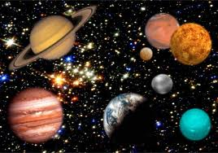

Saturn

Do you have a favorite planet? Which one is it? It might be the gas giant Jupiter, or it could be red, rocky Mars. If your favorite is Saturn, however, then you are in for a treat as we’re going to have a look at this planet - but rather than talking about this gaseous world as a whole, we’re going to focus on one of its very important and most obvious features - its rings. These unusual features, which circle the planet like hula hoops, might be the reason why it’s your favorite - they certainly make Saturn stand out from the crowd and they are also very beautiful. Some astronomers say that it makes Saturn look like it has ears - at least, depending on what angle the rings are tilted towards the Earth - maybe you disagree and think that Saturn looks like a cup with two handles on either side!

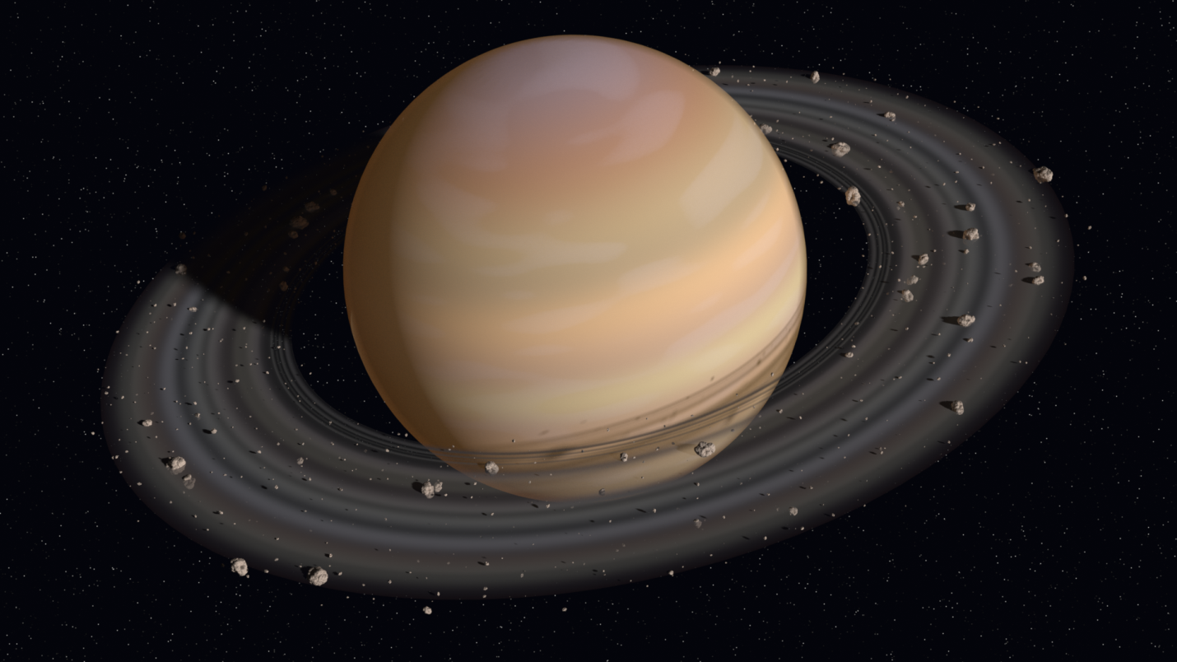

**What are comets?**  
A comet is a small world which scientists sometimes call a planetesimal. They are made out of dust and ice, kind of like a dirty snow ball.

Many people think that a comet's tail is always following behind it, but actually the coma, or tail, can either be behind the comet **or** in front of it. Which way the tail is pointing depends on where the Sun is. That's right, the Sun's heat and radiation produce a wind called the *Solar Wind*, as a comet gets close to the Sun it begins to melt. The gas and dust that melt off are blown away from the Sun by the solar winds. So if a comet is traveling towards the Sun then the tail will follow behind, but if the comet is traveling away from the Sun the tail will be in front of the comet.

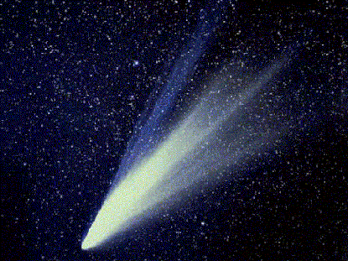

**Earth**

Do you know where you live? With the hustle and bustle of everyday life, it is easy to forget that the human family lives on a small blue planet named Earth. All around us we see trees, animals, cars, buildings, farms, factories, stores, and other natural and man-made structures.

With all of these every day familiar objects around us and with the vast sky above us, and the deep oceans beneath us, our home planet often feels quite large. Compared to us, it is very large. There is enough space for each of us, our families and friends, our pets, as well as trillions of other life forms to live and enjoy the various experiences of life.

While to us, the Earth appears to be a vast wilderness, compared to other objects in the Universe it is actually quite small, in fact, it is so small, that you could say it is tiny.

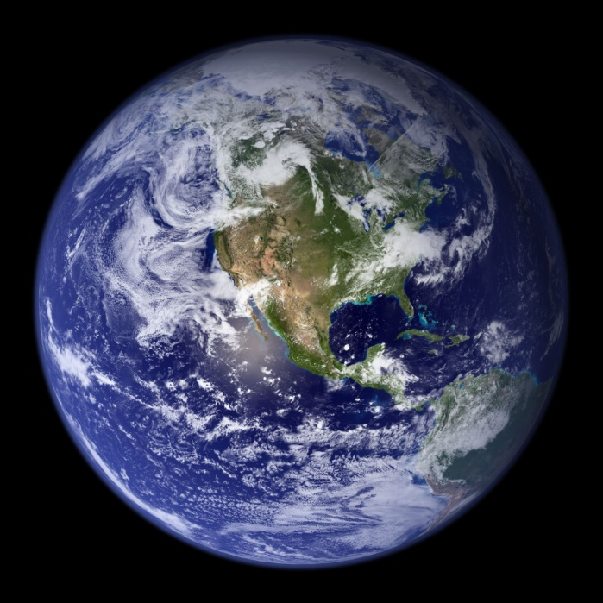

How Big is the Earth?   
The Earth is the biggest of all the terrestrial planets. A terrestrial planet is a dense planet found in the inner Solar System. The diameter of Earth is 7,926 miles. The circumference measured around the equator is 24,901 miles. There are currently almost 7 billion people living on the Earth. About 30% of the Earth's surface is covered with land, while about 70% is covered by oceans.

Moons:   
The Earth has one moon.  Its name is Luna.

Scientists use the Earth to study all the other planets. Since no human has ever visited another planet, we have to use what we know about the Earth, and try to guess what the other planets must be like. This is called Comparative Planetology.

